Machine for the production of Spherical Filling Material EXPLO-CONTROL

Type Ballmatic “2000”
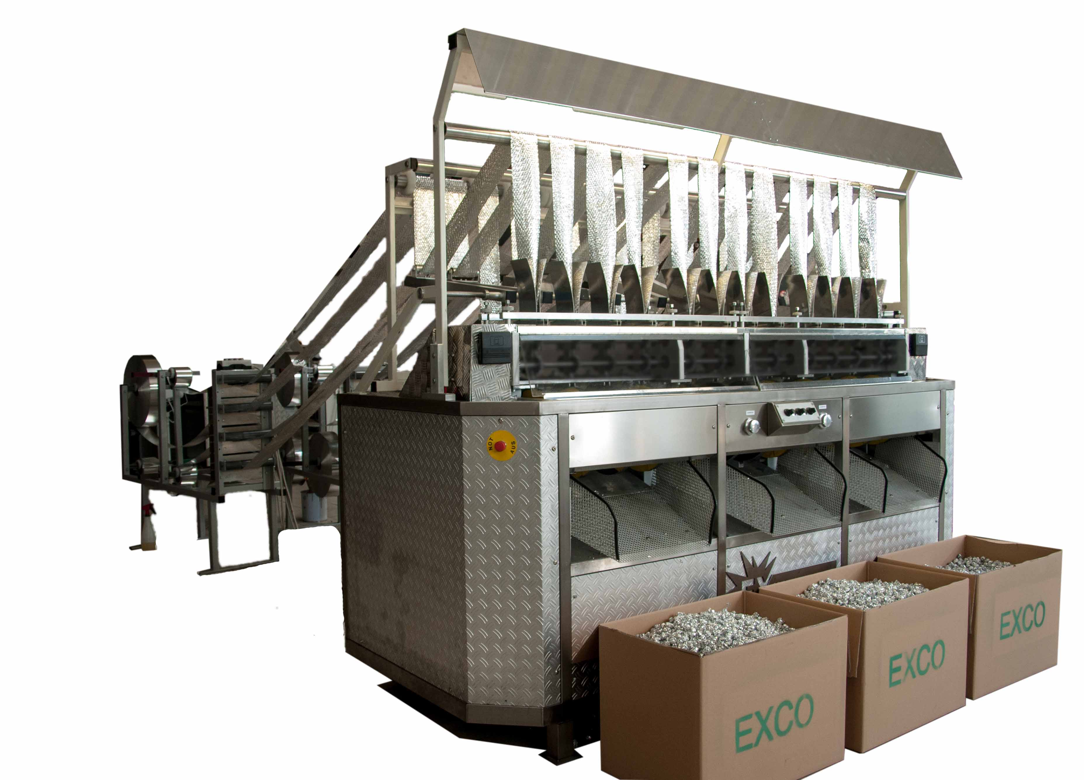

Dimensions and Technical Data

Length 1850 mm
Width 1450 mm
Height 1850 mm
Net weight approx. 300 kg

Power consumption 3kw (400V, 50 Hz)

Capacity 800 –1000 Liter
Balls /Hour by continues running
(Depends on size of the Balls)
Diameter of Balls about 20 – 25 mm

Required material Cutted Aluminium Foil from Network Machine

