Device for filling Gas Bottles and all Kinds of Vessels

Type Fillmatic 2000

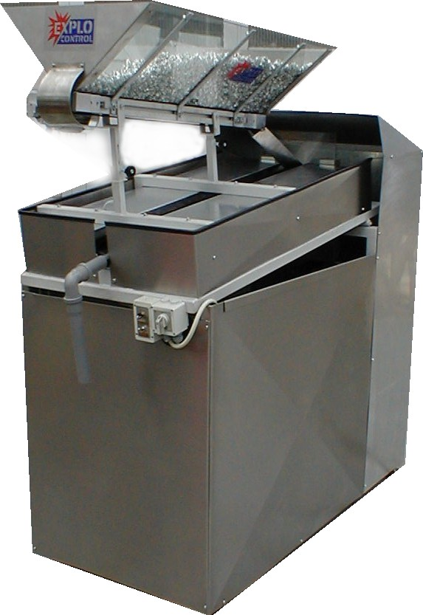

Dimensions and Technical Data

Length 1100 mm
Width 510 mm
Height 2300 mm
Net weight approx. 150 kg

Compressed air required minimum 8 Bar

Capacity less than 1 Minute / 20 Liter (4 Gallon) Gas Bottle

