Machine for the production of Safety-Network EXPLO-CONTROL

Type “Network 2000”
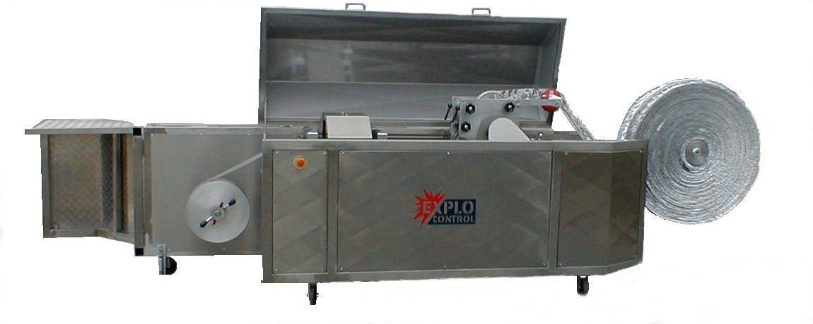

Dimensions and Technical Data

Length 4000 mm
Width 1300 mm
Height 1300 mm
Net weight approx. 350 kg
Power consumption 3kw (400V, 50 Hz)

Capacity 5000 Liter Safety-Network /Hour by
continues running with
Foil 100mm width and 0,050mm strong
and continuously running
Alum foil required 1 kg Foil = 25 – 30 Liter Network

